Finding Bigfoot

Katie Briggs

Bellevue University

28 February 2021

Abstract

The Travel Channel’s television show, Expedition Bigfoot, follows an elite team of bigfoot researchers and a survivalist conducting an exploration of the primate like creature, Bigfoot. They claim in the opening credits that they an advanced algorithm to find to pinpoint the best location to look for bigfoot. The algorithm creates a radius within the pinpointed location and the team camps out and combs the forest for a 17-day timeframe with hopes of capturing evidence. With the increase growth of technology, it is becoming harder for Bigfoot to remain hidden. They use drones, thermal devices, LIDAR and other new technology throughout the series to collect evidence.

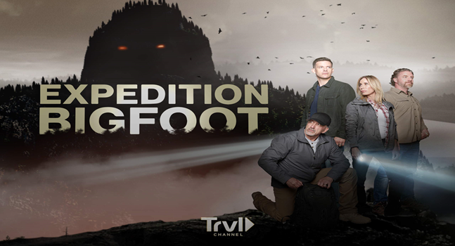
Expedition Bigfoot Promotion Poster – Appendix A
Background

Due to being in the data science field and having a curious nature, I wanted to know what “advanced algorithm” the team was using to conduct their bigfoot research. Every time that I used a search engine to find out it would come up blank. There are no hints whatsoever that the television show is using a real algorithm to help them find bigfoot. The purpose of this project was to see if it was possible to find the best locations to see a bigfoot.

Data

The data sets for the analysis is the Bigfoot Sightings from data.world. It consists of three different reports, bfro_reports.json, bfro_reports_location.csv and brfo_reports_geocoded.csv. For my analysis I utilized the bfro_report_locations and bfro_reports_geocoded files. The variables from the bfro_report_locations that were used were ‘classification’, ‘timestamp’ and the ‘latitude’ and ‘longitude’. The BFRO classification system describes what type of sighting occurred. Class A is a clear sighting in circumstances where misinterpretation or misidentification of other animals can be ruled out with confidence [2]. Class B are incidents where a possible sighting was observed at a great distance or in poor conditions. Class C are second to third hand reports with the potential to be inaccurate.
From the bfro_reports_gecoded the variables that I used to determine relationships were the ‘season’, ‘state’, ‘precipt_type’ and ‘moon_phase’.

Methods
For the analysis, I followed the Cross-Industry Standard Process for Data Mining (CRISP-DM). CRISP-DM is a process encompassing six steps that guide us to develop and implement models from data. These steps are, in order, business understanding, data understanding, data preparation, modeling, evaluation, and deployment. During the business understanding portion, the problem was identified, and a solution was purposed.
For the data understanding step, many references were read and viewed to aid in the understanding of the data set. The background information was attributed to The Bigfoot Field Researchers Organization. During the data preparation stage, missing values were removed, and the data sets were merged. Also, in this step of CRISP-DM the data was explored further with plotting the value counts of the variables with multiple plot libraries.
Python was used to explore the data. The most insightful relationships are below. What is tells me is that sightings occur more during the summer and fall months. Fewer sightings are reported for the Spring and Winter. The difference could be due to people being more active outdoors during the summer and fall. Also, it may indicate that large mammals or primate like creature are possible of hibernating during the winter.
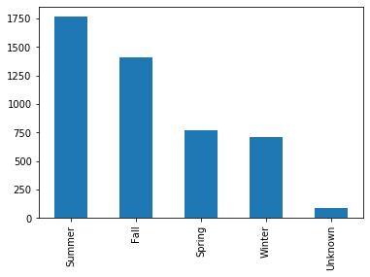
Plot Bigfoot Sightings Grouped by Month – Appendix B
The top ten sightings according to the geocoded report were:
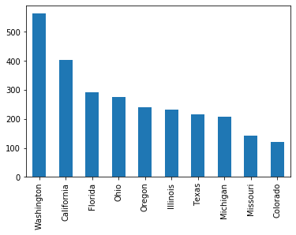
Plot Bigfoot Sightings Grouped by State – Appendix C

The least reported sightings are in colder states and minimal forest dense areas like North Dakota, Rhode Island, Delaware and Nevada.
No outliers were identified within all variables. There were more categorical variables within the data sets. I looked at the relationship between season and moon_phase to determine if the movement of bigfoot was based on the phases of the moon. More sightings were reported during a full moon.
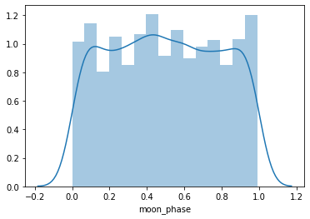
Plot Bigfoot Sightings Grouped by Moon Phase – Appendix D

Results
Once I completed data analysis in Python, I conducted more map analysis and created a cluster using R with the bfro_report_locations dataset. I used leaderCluster library to create a matrix of coordinates and outputs of cluster ids from running the leader algorithm. The coordinates were points based off latitude and longitude pairs, with a radius of 175 miles. I modified the timestamp so that I could use ggplot to plot the sightings by specific month and the percentage. Below we see that the largest percentage is in October which is the same time that the Elk and deer migrate in the Pacific Northwest.
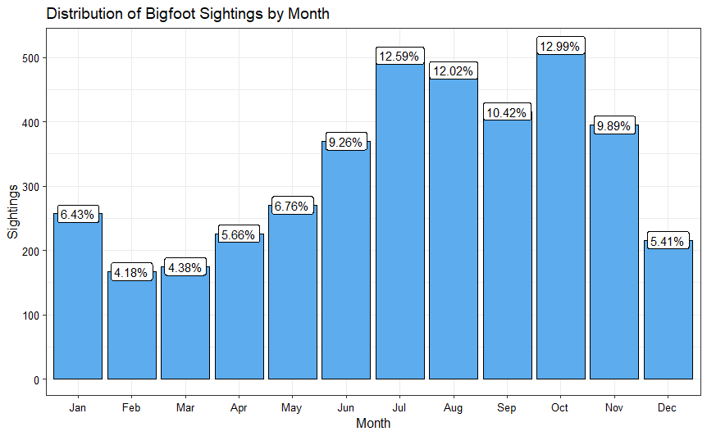
Plot Bigfoot Sightings Grouped by Month – Appendix E

After seeing the breakdown of sightings by month, I filter sightings down by the classification of the encounter and mapped it using the leaflet library. Overfitting of the map happened quickly, so I set the algorithm seed and clustered the data. The top five cluster ids were generated with the 175 mile radius. The area with the most sightings, 11 percent, was throughout Washington state and northern Oregon. Interesting because this is where the first season of Expedition Bigfoot took place with their elite team.
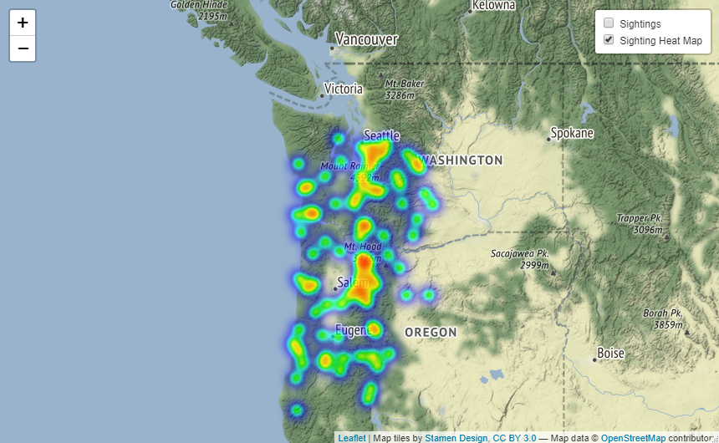
Most Frequent Sightings – Appendix F
During the second season of Expedition Bigfoot the team went to Southeastern Kentucky during the summer to try and gather evidence. What is most compelling, is that the fifth largest cluster throughout North America was eastern Kentucky.
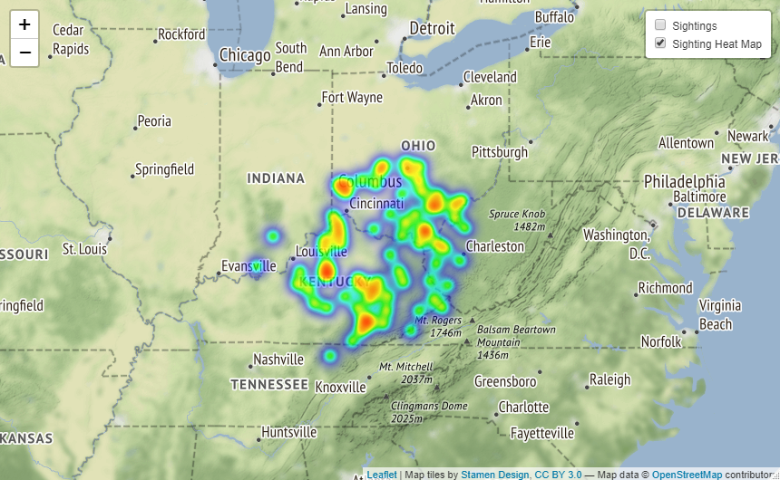
Most Frequent Sightings – Appendix G
Conclusion
Seeing the patterns on the map clusters that were generated and following the television series, I do believe that it possible to use an algorithm to track animal or even bigfoot’s movements.

Acknowledgements
Expedition Bigfoot, The Bigfoot Researcher Organization, data.world, Bellevue University

References:
Full text and Geocoded dataset from The Bigfoot Field Research Organization (BFRO), data.word, with three files, brfo_report_locations.csv, bfro_reports.json, and bfro_reports_gecoded.csv. https://data.world/timothyrenner/bfro-sightings-data

Burton, B., (2020), How Expedition Bigfoot tracks the big beast with drones and algorithms, On Travel Channel’s new show, survivalists, scientists and researchers use the latest high-tech gadgets to look for the elusive Sasquatch. Retrieved from: https://www.cnet.com/news/how-expedition-bigfoot-tracks-the-big-beast-with-drones-and-algorithms/

Dobson, J., (2020), Televised Expedition May Prove The Elusive Beast Is Real, Forbes, Retrieved from: https://www.forbes.com/sites/jimdobson/2019/11/22/in-search-of-bigfoot-a-televised-expedition-may-prove-the-elusive-beast-is-real/?sh=2ac546a43ddd

The Bigfoot Field Researchers Organization, Founded in 1995 and the only scientific research organization exploring bigfoot. A website that allows documentation of bigfoot sighting and evidence. Retrieved from: https://www.bfro.net/

Tableau, Public Bigfoot Sightings within the United States, Retrieved from: https://public.tableau.com/views/BigfootSightingsintheUnitedStates/CountyDashboard?:embed=y&:toolbar=no&:loadOrderID=0&:tabs=no&:showVizHome=no

Guiming Wang, Machine learning for inferring animal behavior from location and movement data, Ecological Informatics, Volume 49, 2019, Pages 69-76, ISSN 1574-9541, https://doi.org/10.1016/j.ecoinf.2018.12.002. (https://www.sciencedirect.com/science/article/pii/S1574954118302036)
Abstract: Movement ecology has rapidly advanced owing to recent developments of animal-attached devices and wide applications of sophisticated statistical and machine learning techniques in analysis of animal movement data. Global Positioning System (GPS) transmitters used for estimating animal locations and tri-axial accelerometers used for measuring the 3-dimensional accelerations of animal's motion aid researchers in collecting location and locomotion data at fine spatial and temporal scales.

Edmond, C., (2019), How AI is Helping Track Endangered Species, Retrieved from: https://news.microsoft.com/on-the-issues/2019/08/06/ai-endangered-species/

Maekawa, T., Ohara, K., Zhang, Y. et al. Deep learning-assisted comparative analysis of animal trajectories with DeepHL. Nat Commun 11, 5316 (2020). https://doi.org/10.1038/s41467-020-19105-0

Dios, E., (2021), Using MapQuest API to Get Geo Data, Retrieved from: https://towardsdatascience.com/tagged/geocoding

Giday, A., (2016), A Million Geocode Data Visualization with ggplot2, Retrieved from: https://rstudio-pubs-static.s3.amazonaws.com/239436_cc5ab5d271ca4c229c01e33d0788b49d.html

Appendix

Appendix A:
Promotion for Expedition Bigfoot

Appendix B: Bigfoot Sightings Grouped by Season

Appendix C: Bigfoot Sightings Grouped By State top 10

Appendix D: Bigfoot Sightings during Moon Phases

Appendix E: Bigfoot Sighting by Month

Appendix F: Largest cluster of Sightings

Appendix G: Fifth largest cluster of Sightings

Ten Questions:

Where are the most sightings of bigfoot being reported?
What season are the most sightings reported?
Why did you choose this project?
Did anything surprise you in the data analysis?
What did not go as planned?
What steps did you take to overcome those obstacles?
Are the results what you expected?
What did you lessons did you learn in this project?
Would you use something like this to track other animals?
What went right during this project?

